MUKESH PATEL SCHOOL OF TECHNOLOGY, MANAGEMENT AND ENGINEERING

Task Management System
Software Requirement Specification
Software Design with Unified Modelling Language Project
Submitted by:

Aayusman Pati (E047)

Submitted to:

………………………. (Dr. Shubha Puthran)

Date of submission: 08/04/26

Table of Contents
1. Introduction 3
1.1 Purpose
1.2 Document Conventions
1.3 Intended Audience and Reading Suggestions
1.4 Product Scope
1.5 References
2. Overall Description 5
2.1 Product Perspective
2.2 Product Functions
2.3 User Classes and Characteristics
2.4 Use Case Diagram
2.5 Sequence Diagram
2.6 Class Diagram
2.7 Activity Diagram
2.8 State Diagram
2.9 Component Diagram
2.10 Package Diagram
2.11 Deployment Diagram
2.12 Operating Environment
2.13 Design and Implementation Constraints
2.14 Assumptions and Dependencies
3. Other Non-Functional Requirements 12
3.1 Performance
3.2 Safety Requirements
3.3 Security Requirements
3.4 Quality Requirements
4. Other Requirements 12
4.1 Legal
4.2 Interfacing
5. External Interface Requirements 13
5.1 User Interfaces
5.1.1 Login Page
5.1.2 Dashboard
5.1.3 Add Task
5.1.4 Calendar
5.1.5 Weekly Summary

Introduction

Purpose
If the SRS is written well it will serve the following purposes. SRS is the agreement document between the client and the Software developer.
- Feedback to the Customer -
This software requirement specification assures the project management stakeholders and client that the development team has really understood the business requirements documentation properly. This also provides confidence that the team will develop the functionality which has been detailed.
- Breaking the Requirements Down -
This document is documented in such a way that it breaks the deliverables into smaller components which makes the participants in this project to understand what is to be done clearly. The information is organized in such a way that all the developers within the team will not only understand the boundaries within which we need to work, but also what functionality needs to be developed and in what order.
Understanding what order the functionality will be developed in means that we, the developers will have the "big picture" view of the development. This gives us an opportunity to plan ahead which saves both project time and cost.
- Facilitating other Documentation -
The SRS forms the basis for a load of other important documents such as the Software Design Specification.

- Product Validation -
It basically helps in validating with the client that the product being delivered, meets what they asked for. Which means that the product we have output is Equal to the standards of the documentation in the SRS which the client satisfied and agreed on.

Characteristics of a Software Requirement Specification
    - Accuracy
We will ensure the accuracy of the software and the data entered to the database

Clarity
This SRS will be clearly stating what the user wants in the software.

Completeness
The software requirement specification contains all the the requirements stated in the business requirements documentation that the user specified.

Consistency
The document is consistent from beginning till the end. It helps the readers understand the requirements well.

Prioritizations of Requirements
The requirements will be fullfilled according to the order of priority and preference.

Verifiability
At the end of the project, the user/client will be able to verify that all that all the agreed deliverables have in fact been produced and meet the project management requirements specified.

Modifiability
The SRS can be modified when the development team and user feel the need.

Traceability
Each requirement stated in the SRS is uniquely associated to a source such as a use case or interaction document etc.

Document Conventions
The document is prepared using Microsoft Word 2024 and has used the font type 'Times New Roman'. The fixed font size that has been used to type this document is 12pt with 1.5 line spacing. It has used the bold property to set the headings of the document. All pages except the cover page are numbered, the numbers appear on the lower right corner of the page.
Every image and data table are numbered and referred to the in the main text
Use case scenario is written according to Alistair Cockburn’s template. Standard IEEE template is the template used to organize the appearance of the document and its flow.

Intended Audience and Reading Suggestions
The intended audience of this document would be the client and specific employees (in case of Educational Institute, like Principal, Teachers, Professors, consultants and System Operators of the respective institute, and project team, supervisor with the objective to refer and analyze the information). The SRS document can be used in any case regarding the requirements of the project and the solutions that have been taken. The document would final provide a clear idea about the system that is building.

Product Scope

The Student Task & Deadline Manager is a web-based application designed to help students organize, track, and manage their academic tasks such as assignments, exams, and projects. It enables users to add tasks, monitor deadlines, and automatically prioritize work based on urgency and task type.

The system provides features like task management, reminders, calendar visualization, and weekly summaries to improve time management and productivity. It aims to reduce missed deadlines and offer a structured approach to handling academic workload efficiently.

References
- https://www.geeksforgeeks.org/node-js/task-management-system-using-node-and-express-js/
- https://otrs.com/blog/processes-workflows/task-management/

Overall Description

Product Perspective
The Student Task & Deadline Manager is a standalone web-based application developed to assist students in organizing and managing their academic tasks efficiently. It operates as a client-server system where the frontend provides an interactive user interface and the backend handles business logic, data processing, and storage using a relational database.

The system is designed with a modular architecture, consisting of components such as authentication, task management, priority calculation, and analytics. These modules interact through well-defined interfaces, ensuring flexibility and ease of maintenance. The application integrates features like automatic priority calculation, reminders, and calendar-based visualization to enhance user experience.

The system does not depend heavily on external services and primarily interacts with a web browser and a local or hosted server environment. It is scalable and can be extended in the future with additional features such as mobile support, advanced analytics, or integration with external tools.

Product Functions
A summary of the major functions that the software will perform:
• The system allows users to register, log in, and securely access their personal task data.
• The system enables users to create, update, and delete academic tasks with details such as subject, deadline, and type.
• The system automatically calculates and assigns priority to tasks based on deadline, task type, and weight.
• The system displays tasks in a dashboard sorted by urgency, highlighting critical and overdue tasks.
• The system generates reminders for tasks approaching their deadlines to prevent missed work.
• The system provides a calendar view to visualize tasks and deadlines on specific dates.
• The system generates weekly summaries and analytics to help users track performance and workload.

User Classes and Characteristics

Student (Primary User)

• Uses the system to manage academic tasks such as assignments, exams, and projects
• Can add, update, delete, and view tasks
• Monitors deadlines, priorities, and reminders
• Views dashboard, calendar, and weekly summaries
• Expected to have basic knowledge of web applications

Administrator (Optional User)
  - Manages overall system settings and ensures smooth operation
  - Can monitor user activity and system performance
  - Handles maintenance and updates if required
  - Requires technical knowledge of the system

Developer / Maintenance Staff
  - Responsible for system updates, debugging, and improvements
  - Uses the SRS and system documentation to understand functionality
  - Ensures system reliability, performance, and security
  - Requires strong technical knowledge of the technology stack

Use Case Diagram
A use case diagram is a representation of the user's interaction with the system summarizing of the relationships between use cases, actors, and systems in which the user is involved.

Use Case Functions and Conditions

- Student (Primary Actor)

• Login / Sign Up
Precondition: User has access to the system and provides valid credentials.
Postcondition: User is authenticated and redirected to the dashboard.

• Add Assignment / Task
Precondition: User is logged into the system.
Postcondition: Task is stored in the database and displayed on the dashboard with assigned priority.

• View Dashboard
Precondition: User is logged in and tasks exist in the system.
Postcondition: Dashboard displays tasks, summaries, and workload insights.

• View Calendar
Precondition: User is logged in.
Postcondition: Tasks and deadlines are displayed in calendar format.

• Mark Task Completed
Precondition: Task exists in the system.
Postcondition: Task status is updated and reflected in dashboard and summary.

- System Admin (Primary Actor)

• Monitor System Activity
Precondition: Admin is logged into the system.
Postcondition: System data and activity are displayed for monitoring.

• View Dashboard Insights
Precondition: System data is available.
Postcondition: Summary and analytics of tasks are displayed.

- Notification System (Secondary Actor)

• Send Reminder Notification
Precondition: Tasks with upcoming or missed deadlines exist.
Postcondition: Reminder notifications are generated and sent to the user.

- System (Internal Processing Actor)

• Auto-Sort Tasks by Urgency
Precondition: At least one task exists in the system.
Postcondition: Tasks are reordered based on priority and deadline.

• Calculate Task Priority
Precondition: Task details such as deadline and type are available.
Postcondition: Priority level is assigned to each task.

• Update Dashboard and Summary
Precondition: Task data is updated or modified.
Postcondition: Dashboard reflects latest task information and analytics.

2.5 Sequence Diagram

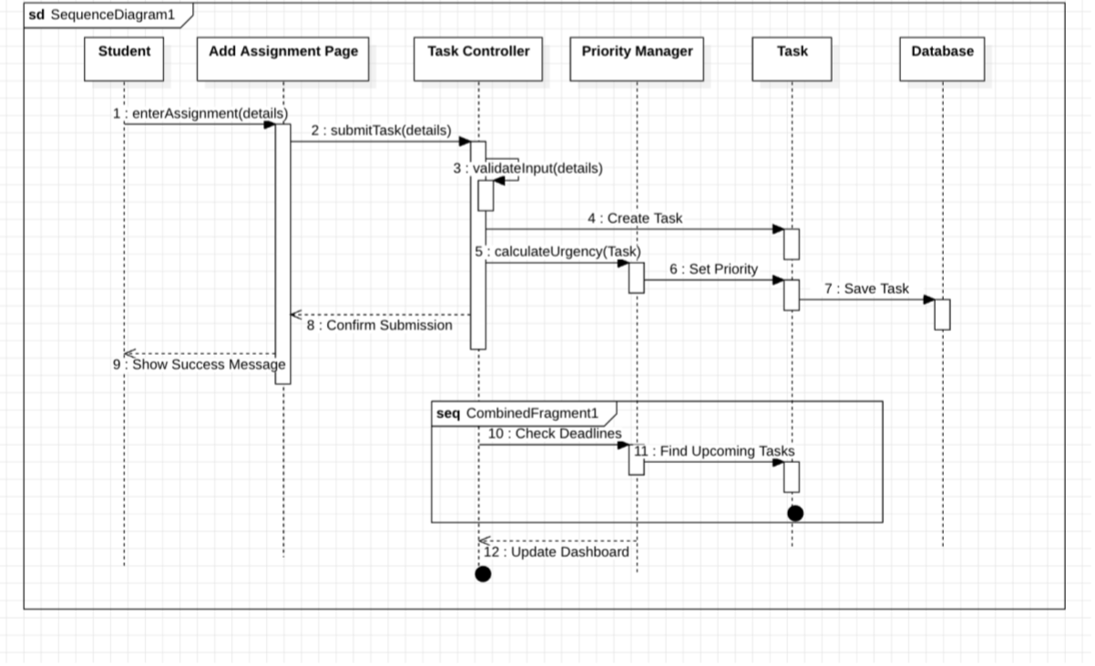

2.6 Class Diagram
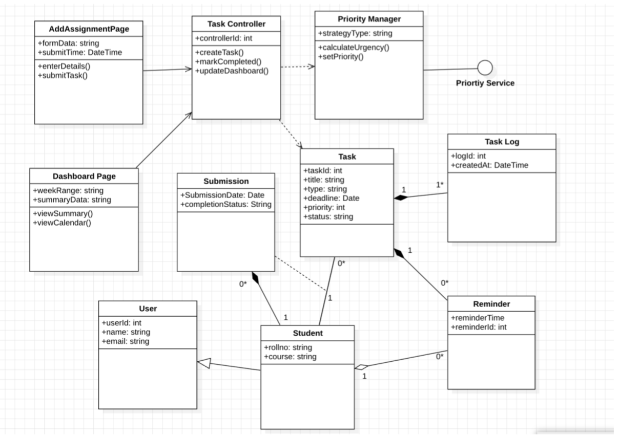

2.7 Activity Diagram
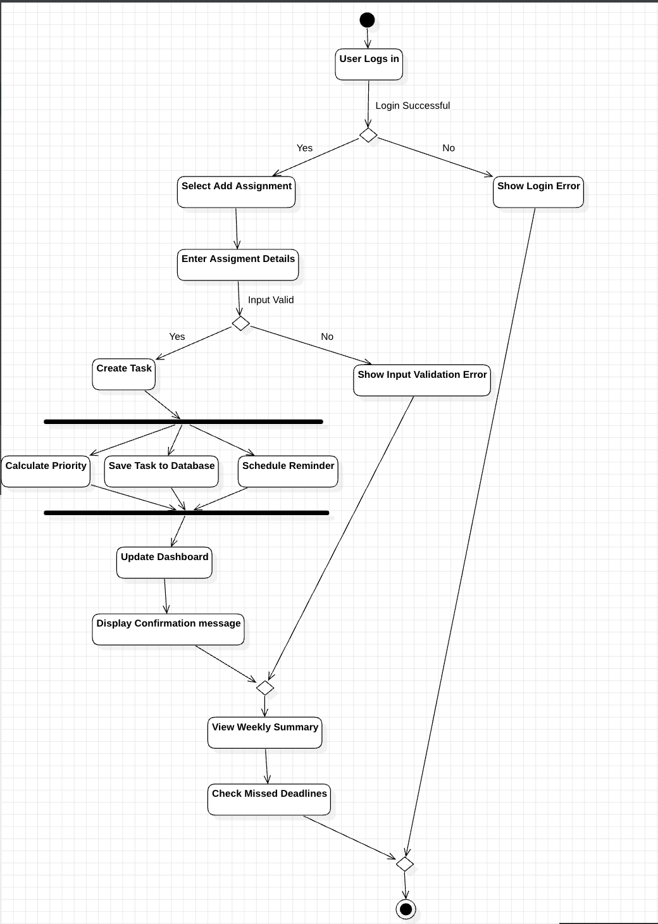

2.8 State Diagram
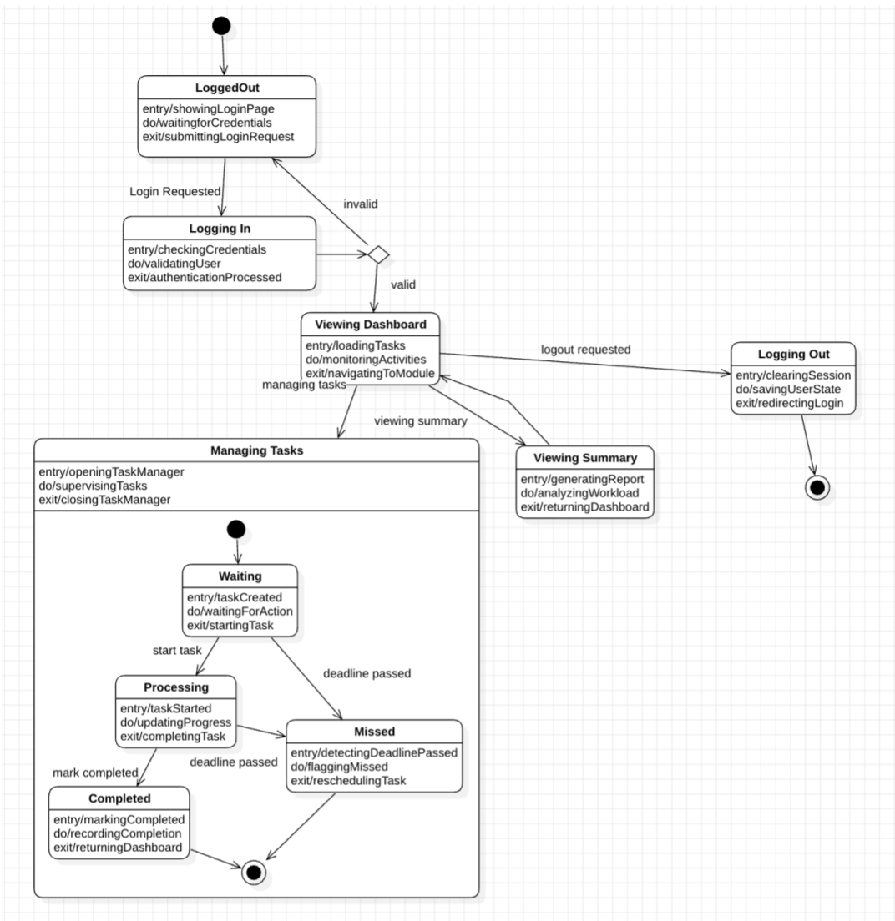

2.9 Component Diagram
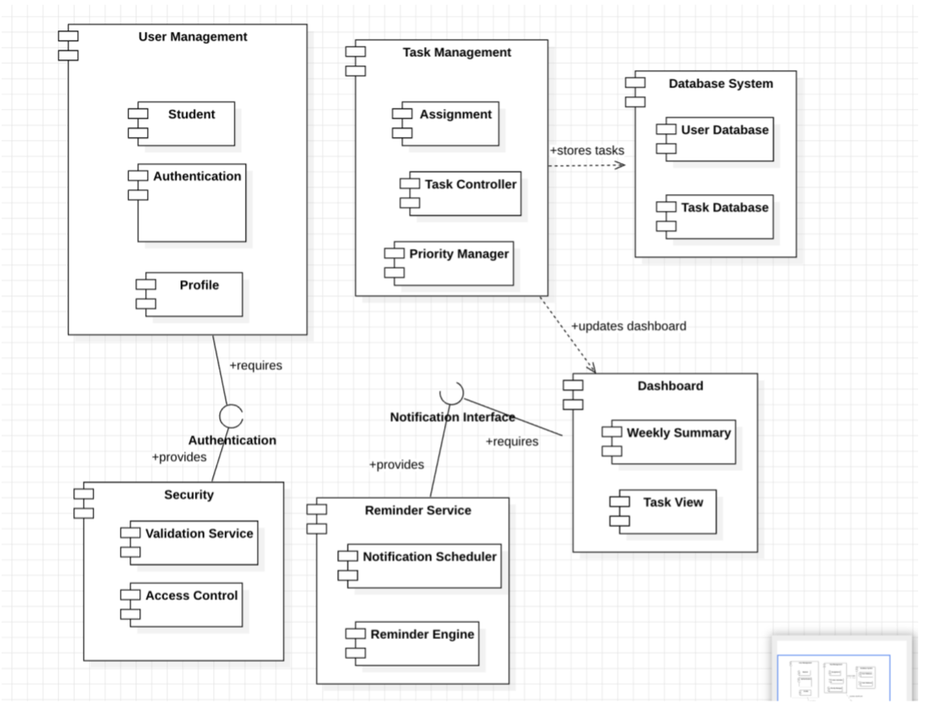

2.10 Package Diagram
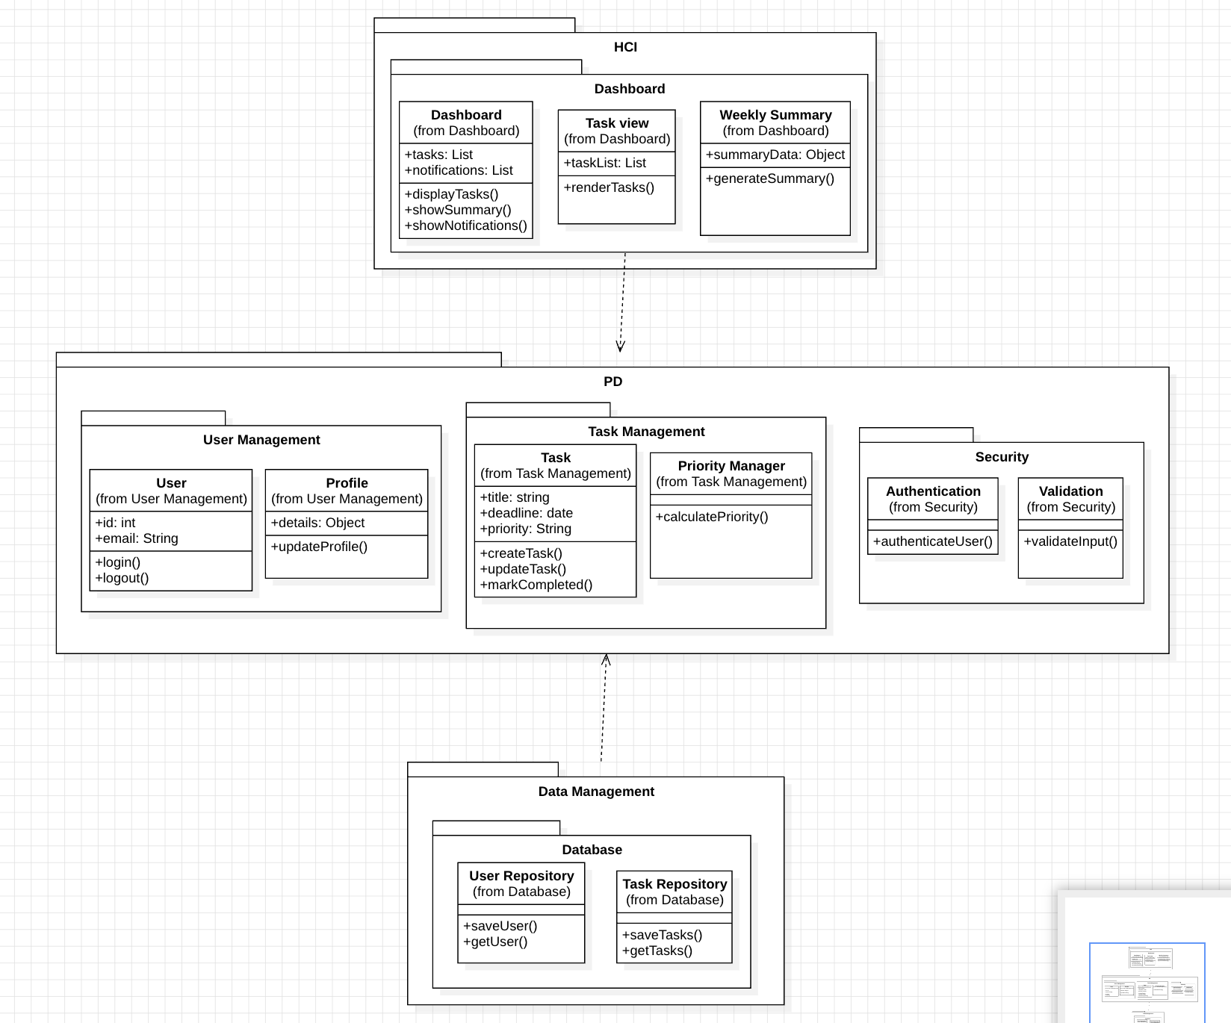

2.11 Deployment Diagram

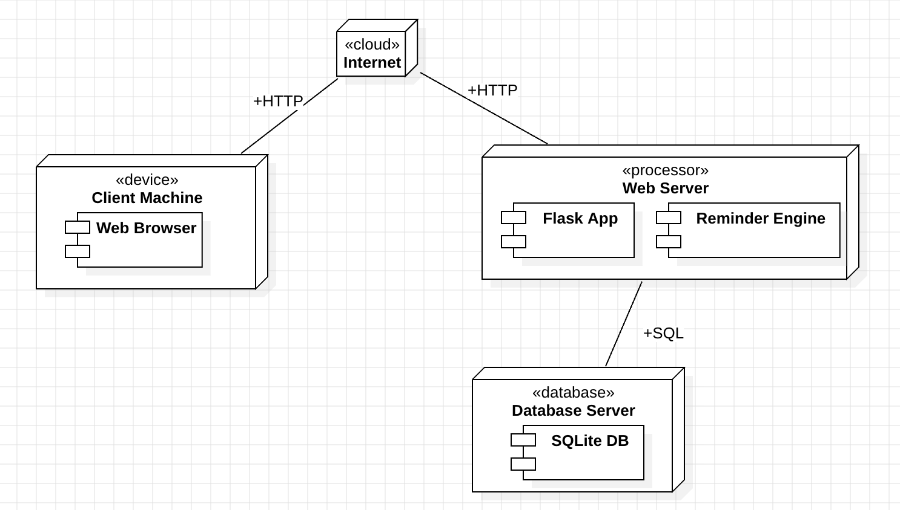

2.12 Operating Environment

1. Software Requirements
• Programming Language: Python
• Framework: Flask
• Database: SQLite
• Operating System: Windows, macOS, or Linux
• Web Browser: Google Chrome, Firefox, or Edge

2. Hardware Requirements
• Processor: Dual-core or higher
• RAM: Minimum 4 GB
• Storage: At least 500 MB free space

2.13 Design and Implementation Constraints

• The system must follow a modular architecture separating frontend, backend, and database components.
• The application must be implemented using Python (Flask) for backend and HTML, CSS, JavaScript for frontend without using frameworks.
• Task priority must be calculated using a predefined algorithm based on deadline, task type, and weight.
• All user inputs must be validated before storing data in the database to ensure accuracy and consistency.
• The system must maintain synchronization between frontend display and backend data at all times.

2.14 Assumptions and Dependencies

• Users have basic knowledge of using web applications.
• The system will be used by students to manage academic tasks.
• The application will run in a standard web browser environment.
• The system depends on a Python (Flask) backend for execution.
• The application depends on an SQLite database for storing data.
• The reminder feature depends on task deadlines and system time.

Other Non-Functional Requirements

Performance

• The system should respond to user actions such as login, task creation, and retrieval within 1–2 seconds under normal conditions.
• Task sorting and priority calculation should be performed without noticeable delay.
• The system should handle multiple users with consistent performance for academic use.

Safety Requirements
• The system should prevent data loss during operations such as task creation, update, or deletion.
• Proper validation should ensure incorrect or incomplete inputs do not affect system functionality.
• Backup or recovery mechanisms should be considered to protect important user data.

Security Requirements
• User authentication must be implemented to restrict unauthorized access.
• Passwords must be stored securely using hashing techniques.
• The system should validate inputs to prevent malicious data entry or attacks.

Quality Requirements
• The system should provide a user-friendly and intuitive interface.
• The application should be reliable and function without frequent errors.
• The system should be maintainable with modular and well-structured code.
• The application should be compatible with standard web browsers.

Other Requirements

Legal

• The system must comply with basic data privacy practices by securely handling user information such as login credentials.
• The application must use open-source tools and libraries in accordance with their licensing terms.

Interfacing

• The system must interact with users through a web browser using standard HTTP communication.
• The frontend must communicate with the backend using RESTful APIs with data exchanged in JSON format.

External Interface Requirements

User Interfaces

Login Page
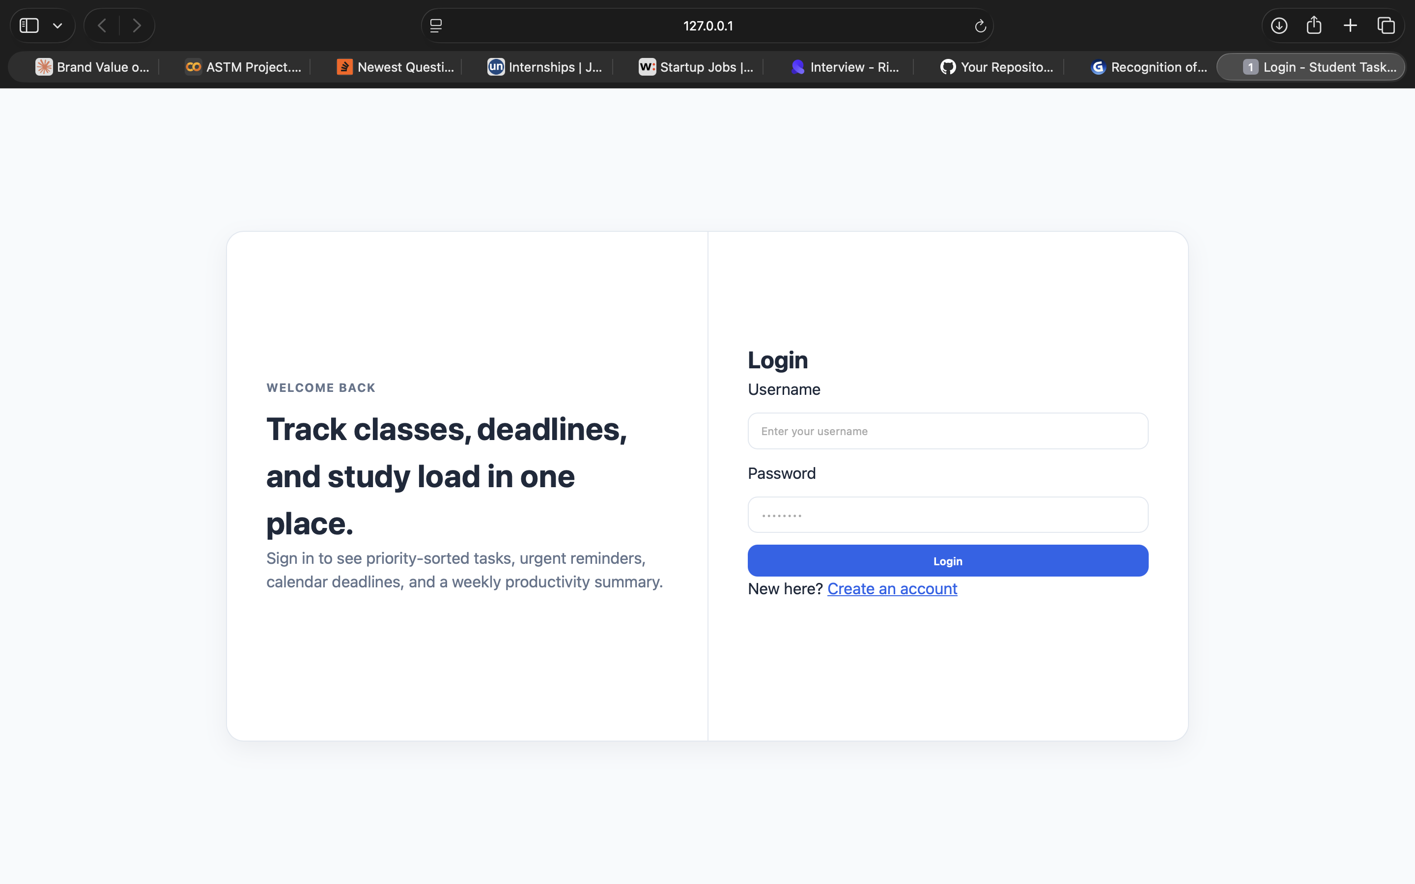

Dashboard
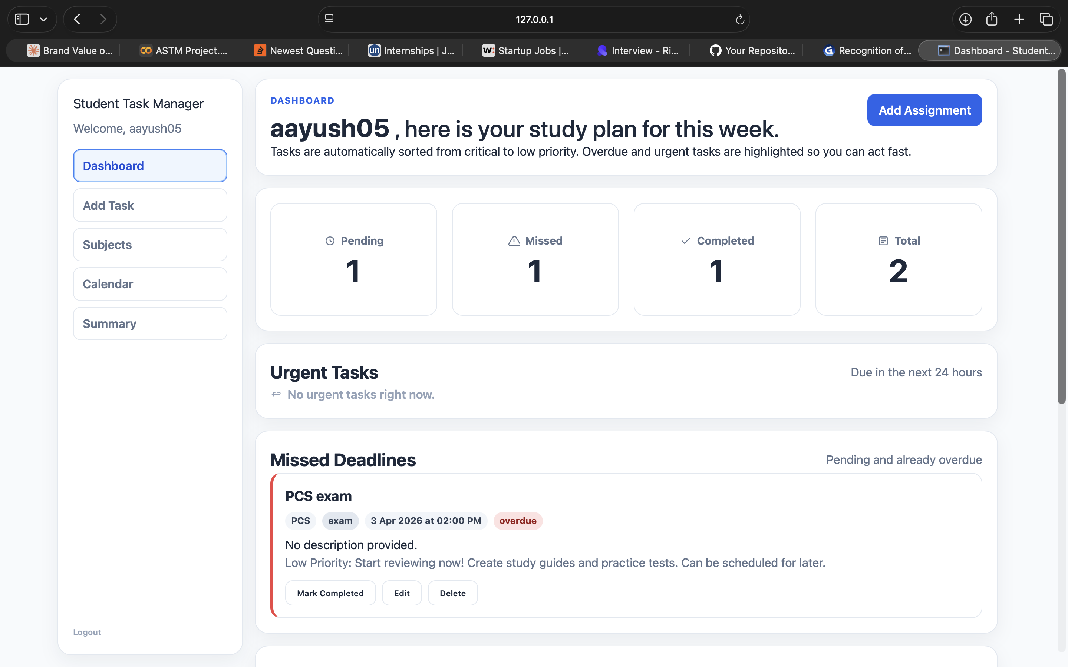

Add Task
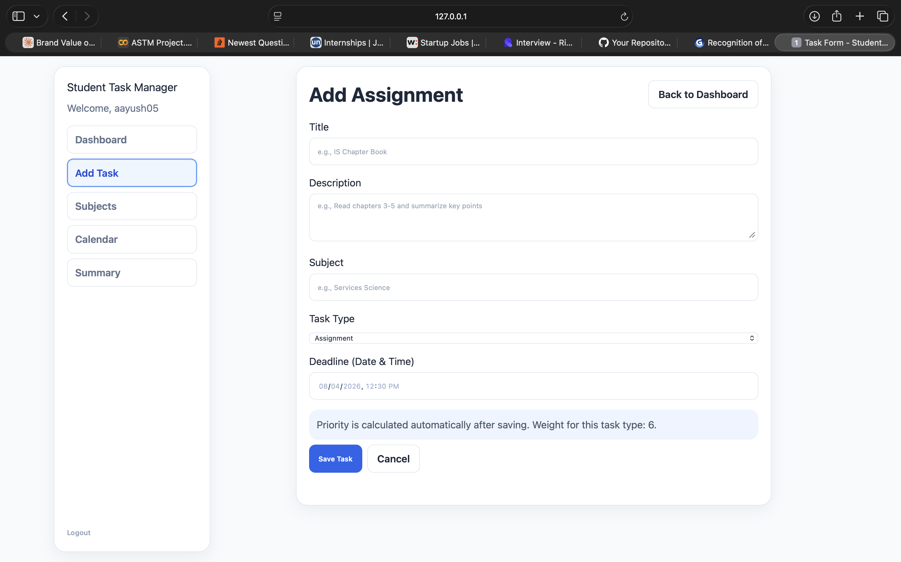

Calendar
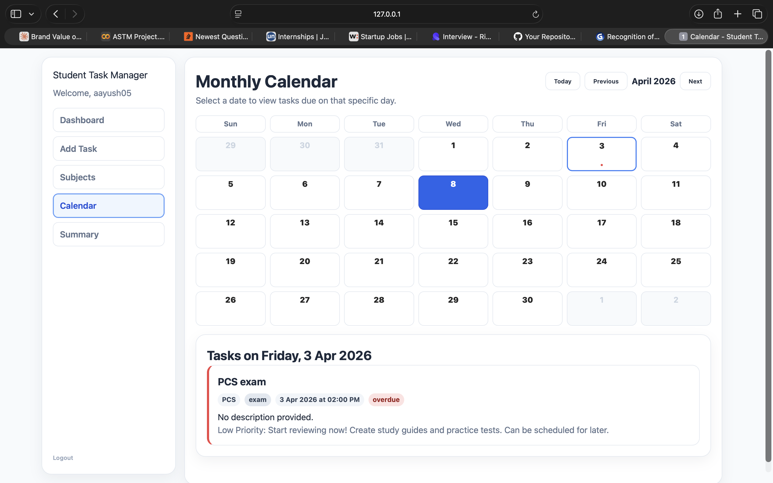

Weekly Summary
